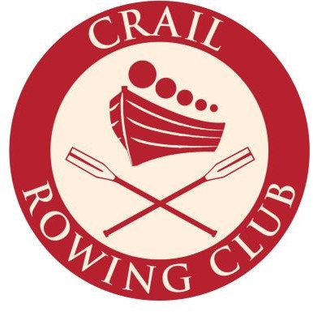

Membership Form

Name
Address
Phone
Email
Date of Birth
Emergency Contact Name
Emergency Contact Phone

ANNUAL MEMBERSHIP FEES

Adult | £45 | Social (non- rowing) | £10 | Student | £30 | Under 18 | Free

I confirm that I have read, understood and agree to abide by the Constitution and Rules & Conditions of Membership.
I give permission for any photograph containing my image to be used for Crail Rowing Club Social Media/Website purposes.

Do you have any particular skills you think might be relevant? For example: Carpentry, DIY, Rowing, Boating, Towing?............................................

Signed................................................................................................

Date....................................................................................................

Please return to David Jerdan by email at david.jerdan@gmail.com
Fee may be paid by bank transfer. Please contact David Jerdan for details.

